V.VENKATA KUMAR REDDY
192311350
INTERNET PROGRAMING-CSA4308

LAB PROGRAMS

1ST PROGRAM
<!DOCTYPE html>
<html lang="en">
<head>
<meta charset="UTF-8">
<meta name="viewport" content="width=device-width, initial-scale=1.0">
<title>Library Management System</title>

<style>
*{
margin:0;
padding:0;
box-sizing:border-box;
font-family:Arial, sans-serif;
}

body{
background:#f2f2f2;
}

header{
background:#2c3e50;
color:white;
padding:20px;
text-align:center;
}

nav{
background:#34495e;
padding:15px;
text-align:center;
}

nav a{
color:white;
text-decoration:none;
margin:20px;
font-size:18px;
}

nav a:hover{
color:yellow;
}

.hero{
padding:50px;
text-align:center;
background:white;
}

.hero h1{
color:#2c3e50;
}

.hero p{
margin-top:15px;
font-size:18px;
}

.container{
display:flex;
justify-content:space-around;
margin:40px;
}

.card{
background:white;
padding:20px;
width:250px;
border-radius:10px;
box-shadow:0 0 10px gray;
text-align:center;
}

.card h3{
margin-bottom:15px;
}

.card button{
background:#2c3e50;
color:white;
padding:10px 20px;
border:none;
cursor:pointer;
margin-top:15px;
}

.card button:hover{
background:#27ae60;
}

footer{
background:#2c3e50;
color:white;
text-align:center;
padding:20px;
margin-top:40px;
}
</style>

</head>
<body>

<header>
<h1>Library Management System</h1>
<p>Online Book Management Portal</p>
</header>

<nav>
<a href="#">Home</a>
<a href="#">Books</a>
<a href="#">Login</a>
<a href="#">Register</a>
<a href="#">Contact</a>
</nav>

<section class="hero">
<h1>Welcome to Library</h1>

<p>
Search books, borrow books, check fines and download study materials.
</p>

</section>

<div class="container">

<div class="card">
<h3>Search Books</h3>
<p>Find books by title, author or category.</p>
<button>Search</button>
</div>

<div class="card">
<h3>Student Login</h3>
<p>View borrowed books and download materials.</p>
<button>Login</button>
</div>

<div class="card">
<h3>Admin Login</h3>
<p>Manage books, students and fines.</p>
<button>Admin</button>
</div>

</div>

<footer>

<p>© 2026 Library Management System</p>

</footer>

</body>
</html>
OUT PUT:

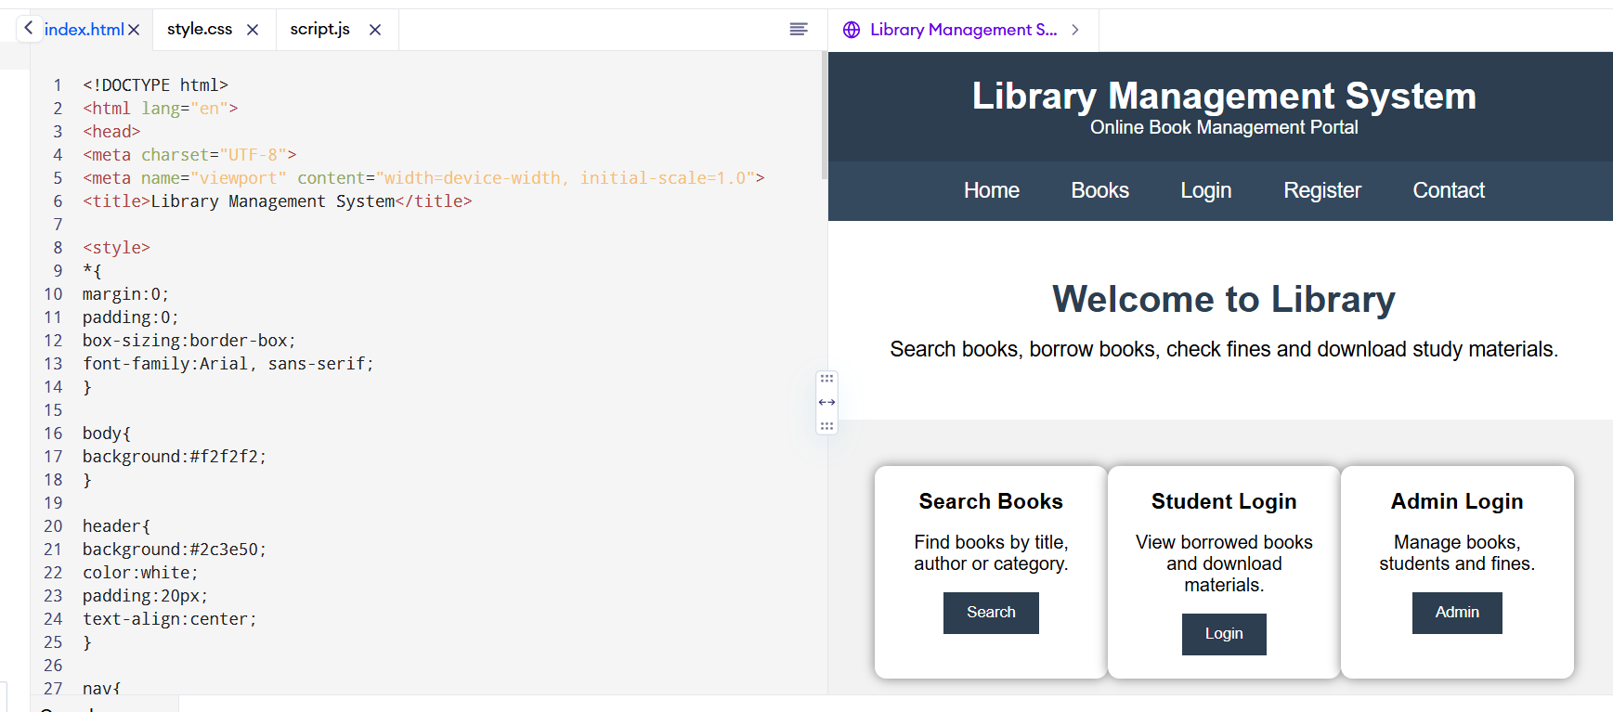

2)PROGRAM
<!DOCTYPE html>
<html lang="en">
<head>
<meta charset="UTF-8">
<meta name="viewport" content="width=device-width, initial-scale=1.0">
<title>Online Hotel Booking System</title>

<style>
*{
margin:0;
padding:0;
box-sizing:border-box;
font-family:Arial, Helvetica, sans-serif;
}

body{
background:#f4f4f4;
}

header{
background:#0d47a1;
color:white;
padding:20px;
text-align:center;
}

nav{
background:#1565c0;
padding:15px;
text-align:center;
}

nav a{
color:white;
text-decoration:none;
margin:15px;
font-size:18px;
}

nav a:hover{
color:yellow;
}

.hero{
background:url("https://images.unsplash.com/photo-1566073771259-6a8506099945?w=1600") center/cover;
height:450px;
display:flex;
justify-content:center;
align-items:center;
color:white;
text-align:center;
}

.hero h1{
font-size:45px;
}

.search-box{
background:white;
width:90%;
max-width:1000px;
margin:-50px auto 30px;
padding:20px;
border-radius:10px;
box-shadow:0 0 10px gray;
}

.search-box form{
display:grid;
grid-template-columns:repeat(auto-fit,minmax(180px,1fr));
gap:15px;
}

input,select{
padding:10px;
font-size:16px;
}

button{
background:#1565c0;
color:white;
border:none;
padding:12px;
cursor:pointer;
font-size:16px;
}

button:hover{
background:#0d47a1;
}

.section{
padding:40px;
}

.cards{
display:flex;
flex-wrap:wrap;
justify-content:center;
gap:20px;
}

.card{
background:white;
width:280px;
border-radius:10px;
box-shadow:0 0 10px #ccc;
overflow:hidden;
}

.card img{
width:100%;
height:180px;
}

.card h3{
padding:10px;
}

.card p{
padding:0 10px 10px;
}

footer{
background:#0d47a1;
color:white;
text-align:center;
padding:20px;
margin-top:30px;
}
</style>

</head>
<body>

<header>
<h1>Online Hotel Room Booking System</h1>
<p>Book Luxury Rooms at Affordable Prices</p>
</header>

<nav>
<a href="#">Home</a>
<a href="#">Rooms</a>
<a href="#">Booking</a>
<a href="#">About Us</a>
<a href="#">Contact</a>
<a href="#">Login</a>
<a href="#">Register</a>
</nav>

<div class="hero">
<div>
<h1>Find Your Perfect Stay</h1>
<p>Easy Online Hotel Booking</p>
</div>
</div>

<div class="search-box">

<form>

<input type="text" placeholder="Destination">

<input type="date">

<input type="date">

<select>
<option>1 Guest</option>
<option>2 Guests</option>
<option>3 Guests</option>
<option>4 Guests</option>
</select>

<button>Search Rooms</button>

</form>

</div>

<section class="section">

<h2 align="center">Room Types</h2>

<br>

<div class="cards">

<div class="card">
<img src="https://via.placeholder.com/300x180" alt="Standard Room">
<h3>Standard Room</h3>
<p>Free Wi-Fi, TV, AC, Queen Bed</p>
<p><b>$80 / Night</b></p>
<button>Book Now</button>
</div>

<div class="card">
<img src="https://via.placeholder.com/300x180" alt="Deluxe Room">
<h3>Deluxe Room</h3>
<p>King Bed, Breakfast Included</p>
<p><b>$120 / Night</b></p>
<button>Book Now</button>
</div>

<div class="card">
<img src="https://via.placeholder.com/300x180" alt="Suite">
<h3>Executive Suite</h3>
<p>Luxury Suite with Balcony</p>
<p><b>$180 / Night</b></p>
<button>Book Now</button>
</div>

<div class="card">
<img src="https://via.placeholder.com/300x180" alt="Family Room">
<h3>Family Room</h3>
<p>Large Room for Families</p>
<p><b>$220 / Night</b></p>
<button>Book Now</button>
</div>

</div>

</section>

<section class="section">

<h2>About Us</h2>

<p>
Our Online Hotel Booking System provides a simple and secure way to book hotel rooms.
Users can search rooms, check availability, manage bookings, and enjoy a comfortable stay.
</p>

</section>

<section class="section">

<h2>Customer Service Q & A</h2>

<ul>
<li>✔ Free cancellation up to 3 days before arrival.</li>
<li>✔ Secure online payment.</li>
<li>✔ 24×7 customer support.</li>
<li>✔ Instant booking confirmation.</li>
</ul>

</section>

<section class="section">

<h2>Contact Us</h2>

<p>Email: support@hotelbooking.com</p>
<p>Phone: +1 9876543210</p>
<p>Address: 123 Main Street, City</p>

</section>

<footer>

<p>© 2026 Online Hotel Booking System | Privacy Policy</p>

</footer>

</body>
</html>
OUTPUT :
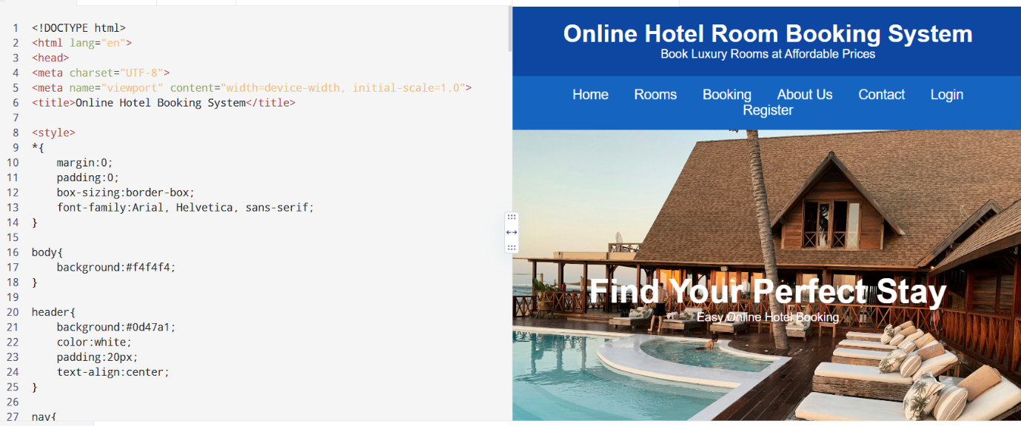

3)PROGRAM
<!DOCTYPE html>
<html lang="en">
<head>
<meta charset="UTF-8">
<meta name="viewport" content="width=device-width, initial-scale=1.0">
<title>Online Bus Ticket Booking System</title>

<style>
*{
margin:0;
padding:0;
box-sizing:border-box;
font-family:Arial, Helvetica, sans-serif;
}

body{
background:#f4f4f4;
}

header{
background:#0066cc;
color:white;
text-align:center;
padding:20px;
}

nav{
background:#004d99;
padding:15px;
text-align:center;
}

nav a{
color:white;
text-decoration:none;
margin:15px;
font-size:18px;
}

nav a:hover{
color:yellow;
}

.hero{
background:#0099ff;
color:white;
text-align:center;
padding:60px 20px;
}

.search{
background:white;
width:90%;
max-width:1000px;
margin:20px auto;
padding:20px;
border-radius:8px;
box-shadow:0 0 10px gray;
}

.search form{
display:grid;
grid-template-columns:repeat(auto-fit,minmax(180px,1fr));
gap:15px;
}

input,select{
padding:10px;
font-size:16px;
}

button{
background:#0066cc;
color:white;
border:none;
padding:12px;
cursor:pointer;
}

button:hover{
background:#004d99;
}

.section{
padding:40px;
}

.cards{
display:flex;
flex-wrap:wrap;
justify-content:center;
gap:20px;
}

.card{
background:white;
width:280px;
padding:20px;
border-radius:10px;
box-shadow:0 0 8px gray;
}

.card h3{
color:#0066cc;
margin-bottom:10px;
}

footer{
background:#004d99;
color:white;
text-align:center;
padding:20px;
margin-top:30px;
}
</style>

</head>
<body>

<header>
<h1>Online Bus Ticket Booking System</h1>
<p>Book Your Journey Anytime, Anywhere</p>
</header>

<nav>
<a href="#">Home</a>
<a href="#">Search Bus</a>
<a href="#">Book Ticket</a>
<a href="#">Booking History</a>
<a href="#">Login</a>
<a href="#">Register</a>
<a href="#">Contact</a>
</nav>

<section class="hero">
<h1>Find & Book Your Bus Tickets</h1>
<p>Easy • Secure • Fast Booking</p>
</section>

<div class="search">

<h2>Search Bus</h2>
<br>

<form>

<input type="text" placeholder="From">

<input type="text" placeholder="To">

<input type="date">

<select>
<option>Select Time</option>
<option>Morning</option>
<option>Afternoon</option>
<option>Evening</option>
<option>Night</option>
</select>

<button type="submit">Search Bus</button>

</form>

</div>

<section class="section">

<h2 align="center">Available Bus Categories</h2>
<br>

<div class="cards">

<div class="card">
<h3>Volvo Bus</h3>
<p>Luxury AC Bus with Pushback Seats</p>
<p>Available Seats : 30</p>
<button>Book Now</button>
</div>

<div class="card">
<h3>Sleeper Coach</h3>
<p>Comfortable Sleeper Berths</p>
<p>Available Seats : 18</p>
<button>Book Now</button>
</div>

<div class="card">
<h3>AC Coach</h3>
<p>Air Conditioned Coach</p>
<p>Available Seats : 25</p>
<button>Book Now</button>
</div>

<div class="card">
<h3>Non-AC Coach</h3>
<p>Economy Travel Option</p>
<p>Available Seats : 35</p>
<button>Book Now</button>
</div>

</div>

</section>

<section class="section">

<h2>User Services</h2>

<ul>
<li>✔ User Registration</li>
<li>✔ User Login</li>
<li>✔ Search Buses</li>
<li>✔ Book Tickets</li>
<li>✔ Cancel Tickets</li>
<li>✔ View Booking History</li>
<li>✔ View Seat Availability</li>
<li>✔ Secure Online Payment</li>
</ul>

</section>

<section class="section">

<h2>Administrator Services</h2>

<ul>
<li>✔ Admin Login</li>
<li>✔ Manage Bus Categories</li>
<li>✔ Add / Update Bus Information</li>
<li>✔ Manage Users</li>
<li>✔ Manage Seat Availability</li>
<li>✔ Generate Reports</li>
<li>✔ Manage News</li>
<li>✔ Manage Comments</li>
</ul>

</section>

<section class="section">

<h2>Customer Comments</h2>

<textarea rows="5" cols="70"
placeholder="Write your feedback here..."></textarea>

<br><br>

<button>Post Comment</button>

</section>

<section class="section">

<h2>Contact Us</h2>

<p>Email : support@busticket.com</p>

<p>Phone : +1 9876543210</p>

<p>Address : Bus Booking Center, Main City</p>

</section>

<footer>

<p>© 2026 Online Bus Ticket Booking System | All Rights Reserved</p>

</footer>

</body>
</html>
OUT PUT:
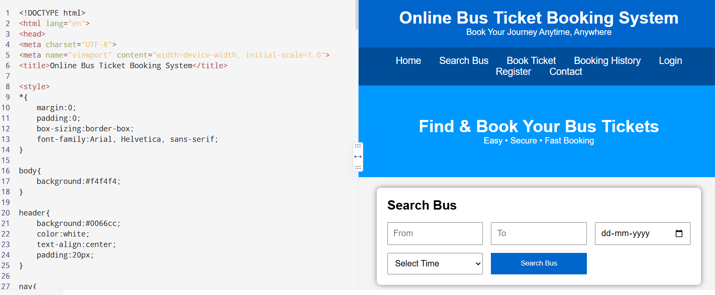

4)PROGRAM
<!DOCTYPE html>
<html lang="en">
<head>
<meta charset="UTF-8">
<meta name="viewport" content="width=device-width, initial-scale=1.0">
<title>Online Train Reservation System</title>

<style>
*{
margin:0;
padding:0;
box-sizing:border-box;
font-family:Arial, sans-serif;
}

body{
background:#f4f4f4;
}

header{
background:#00695c;
color:white;
text-align:center;
padding:20px;
}

nav{
background:#004d40;
padding:15px;
text-align:center;
}

nav a{
color:white;
text-decoration:none;
margin:15px;
font-size:18px;
}

nav a:hover{
color:yellow;
}

.hero{
background:#26a69a;
color:white;
text-align:center;
padding:60px 20px;
}

.container{
width:90%;
max-width:1100px;
margin:auto;
}

.search-box{
background:white;
padding:20px;
margin-top:20px;
border-radius:8px;
box-shadow:0 0 10px gray;
}

form{
display:grid;
grid-template-columns:repeat(auto-fit,minmax(180px,1fr));
gap:15px;
}

input,select{
padding:10px;
font-size:16px;
}

button{
background:#00695c;
color:white;
border:none;
padding:12px;
cursor:pointer;
}

button:hover{
background:#004d40;
}

.section{
margin-top:30px;
background:white;
padding:20px;
border-radius:8px;
box-shadow:0 0 10px #ccc;
}

table{
width:100%;
border-collapse:collapse;
margin-top:15px;
}

table,th,td{
border:1px solid #999;
}

th,td{
padding:10px;
text-align:center;
}

th{
background:#00695c;
color:white;
}

footer{
background:#004d40;
color:white;
text-align:center;
padding:20px;
margin-top:30px;
}
</style>

</head>
<body>

<header>
<h1>Online Train Reservation System</h1>
<p>Book Your Train Tickets Easily</p>
</header>

<nav>
<a href="#">Home</a>
<a href="#">Search Trains</a>
<a href="#">PNR Status</a>
<a href="#">Booking History</a>
<a href="#">Login</a>
<a href="#">Register</a>
<a href="#">Contact</a>
</nav>

<section class="hero">
<h1>Search & Reserve Train Tickets</h1>
<p>Fast • Secure • Easy Booking</p>
</section>

<div class="container">

<div class="search-box">

<h2>Train Search</h2>
<br>

<form>

<input type="text" placeholder="From Station">

<input type="text" placeholder="To Station">

<input type="date">

<select>
<option>Select Class</option>
<option>Sleeper (SL)</option>
<option>3A</option>
<option>2A</option>
<option>1A</option>
<option>Chair Car (CC)</option>
</select>

<button type="submit">Search Trains</button>

</form>

</div>

<div class="section">

<h2>Available Trains</h2>

<table>

<tr>
<th>Train No</th>
<th>Train Name</th>
<th>Departure</th>
<th>Arrival</th>
<th>Seats</th>
<th>Action</th>
</tr>

<tr>
<td>12627</td>
<td>Karnataka Express</td>
<td>08:00</td>
<td>18:30</td>
<td>Available</td>
<td><button>Book</button></td>
</tr>

<tr>
<td>12723</td>
<td>Telangana Express</td>
<td>09:30</td>
<td>20:15</td>
<td>Available</td>
<td><button>Book</button></td>
</tr>

<tr>
<td>12650</td>
<td>Sampark Kranti</td>
<td>11:00</td>
<td>22:00</td>
<td>RAC</td>
<td><button>Book</button></td>
</tr>

</table>

</div>

<div class="section">

<h2>Check PNR Status</h2>

<br>

<input type="text" placeholder="Enter PNR Number">

<button>Check Status</button>

</div>

<div class="section">

<h2>Passenger Services</h2>

<ul>
<li>User Registration & Login</li>
<li>Train Search</li>
<li>Seat Availability</li>
<li>Book Tickets</li>
<li>Online / Offline Payment</li>
<li>Booking History</li>
<li>Print Ticket</li>
<li>Cancel Ticket</li>
<li>Refund Status</li>
<li>PNR Status Check</li>
</ul>

</div>

<div class="section">

<h2>Administrator Services</h2>

<ul>
<li>Manage Train Details</li>
<li>Manage Routes</li>
<li>Manage Seat Availability</li>
<li>Manage Users</li>
<li>Update Fare Details</li>
<li>Manage Refund Rules</li>
<li>Generate Reports</li>
<li>View Payment Details</li>
</ul>

</div>

<div class="section">

<h2>Contact Us</h2>

<p>Email: support@trainreservation.com</p>
<p>Phone: +1 9876543210</p>
<p>Address: Railway Reservation Office</p>

</div>

</div>

<footer>

<p>© 2026 Online Train Reservation System | All Rights Reserved</p>

</footer>

</body>
</html>
OUTPUT:
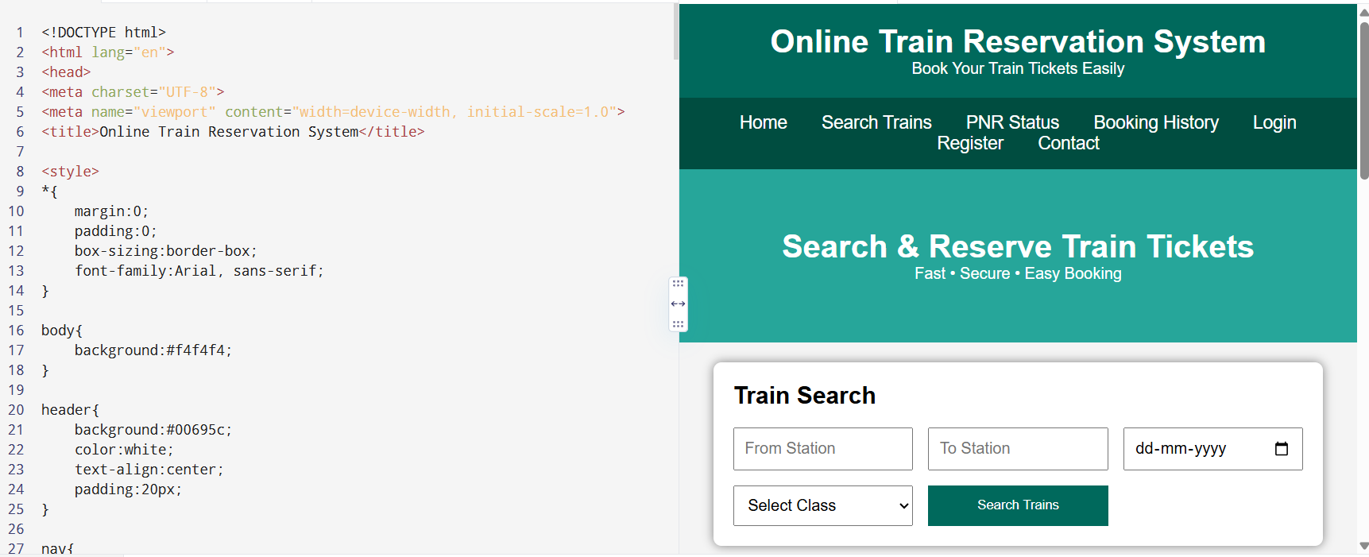

5)PROGRAM
<!DOCTYPE html>
<html lang="en">
<head>
<meta charset="UTF-8">
<meta name="viewport" content="width=device-width, initial-scale=1.0">
<title>Online Flight Reservation System</title>

<style>
*{
margin:0;
padding:0;
box-sizing:border-box;
font-family:Arial, sans-serif;
}

body{
background:#f5f5f5;
}

header{
background:#0b5394;
color:white;
text-align:center;
padding:20px;
}

nav{
background:#073763;
padding:15px;
text-align:center;
}

nav a{
color:white;
text-decoration:none;
margin:15px;
font-size:18px;
}

nav a:hover{
color:yellow;
}

.hero{
background:#4a90e2;
color:white;
text-align:center;
padding:60px;
}

.container{
width:90%;
max-width:1100px;
margin:auto;
}

.search{
background:white;
margin-top:20px;
padding:20px;
border-radius:10px;
box-shadow:0 0 10px #bbb;
}

form{
display:grid;
grid-template-columns:repeat(auto-fit,minmax(180px,1fr));
gap:15px;
}

input,select{
padding:10px;
font-size:16px;
}

button{
background:#0b5394;
color:white;
border:none;
padding:12px;
cursor:pointer;
}

button:hover{
background:#073763;
}

.section{
background:white;
margin-top:25px;
padding:20px;
border-radius:10px;
box-shadow:0 0 10px #ccc;
}

table{
width:100%;
border-collapse:collapse;
margin-top:15px;
}

table,th,td{
border:1px solid gray;
}

th{
background:#0b5394;
color:white;
}

th,td{
padding:10px;
text-align:center;
}

footer{
background:#073763;
color:white;
text-align:center;
padding:20px;
margin-top:30px;
}
</style>

</head>

<body>

<header>
<h1>Online Flight Reservation System</h1>
<p>Book Domestic & International Flights</p>
</header>

<nav>
<a href="#">Home</a>
<a href="#">Search Flights</a>
<a href="#">Book Ticket</a>
<a href="#">My Ticket</a>
<a href="#">Booking Status</a>
<a href="#">Login</a>
<a href="#">Register</a>
<a href="#">Contact</a>
</nav>

<section class="hero">
<h1>Fly Safely, Fly Comfortably</h1>
<p>Search • Book • Travel</p>
</section>

<div class="container">

<div class="search">

<h2>Search Flight</h2>
<br>

<form>

<input type="text" placeholder="From">

<input type="text" placeholder="To">

<input type="date">

<select>
<option>Economy</option>
<option>Premium Economy</option>
<option>Business</option>
<option>First Class</option>
</select>

<button>Search Flight</button>

</form>

</div>

<div class="section">

<h2>Available Flights</h2>

<table>

<tr>
<th>Flight No</th>
<th>Airline</th>
<th>Departure</th>
<th>Arrival</th>
<th>Seats</th>
<th>Fare</th>
<th>Action</th>
</tr>

<tr>
<td>AI101</td>
<td>Air India</td>
<td>08:00 AM</td>
<td>10:15 AM</td>
<td>25</td>
<td>$180</td>
<td><button>Book</button></td>
</tr>

<tr>
<td>6E305</td>
<td>IndiGo</td>
<td>11:30 AM</td>
<td>01:45 PM</td>
<td>18</td>
<td>$150</td>
<td><button>Book</button></td>
</tr>

<tr>
<td>SG220</td>
<td>SpiceJet</td>
<td>04:00 PM</td>
<td>06:20 PM</td>
<td>10</td>
<td>$170</td>
<td><button>Book</button></td>
</tr>

</table>

</div>

<div class="section">

<h2>Passenger Services</h2>

<ul>
<li>✔ User Registration</li>
<li>✔ User Login</li>
<li>✔ Search Flights</li>
<li>✔ Book Tickets</li>
<li>✔ Secure Online Payment</li>
<li>✔ View Booking Status</li>
<li>✔ Print E-Ticket</li>
<li>✔ Cancel Ticket</li>
<li>✔ Booking History</li>
<li>✔ Customer Feedback</li>
</ul>

</div>

<div class="section">

<h2>Administrator Services</h2>

<ul>
<li>✔ Admin Login</li>
<li>✔ Forgot Password</li>
<li>✔ Manage Flights</li>
<li>✔ Manage Seat Availability</li>
<li>✔ Manage Flight Schedules</li>
<li>✔ Manage Users</li>
<li>✔ Generate Reports</li>
<li>✔ View Ticket Payments</li>
</ul>

</div>

<div class="section">

<h2>Customer Feedback</h2>

<textarea rows="5" cols="70" placeholder="Write your feedback here..."></textarea>

<br><br>

<button>Submit Feedback</button>

</div>

<div class="section">

<h2>Contact Us</h2>

<p>Email: support@flightbooking.com</p>
<p>Phone: +1 9876543210</p>
<p>Address: International Airport, Main City</p>

</div>

</div>

<footer>

<p>© 2026 Online Flight Reservation System | All Rights Reserved</p>

</footer>

</body>
</html>
OUTPUT:
